Design Principles - SOLID Principles
# Source: AI Source: Provided by: [Data Path: Persons Table -> ID Column: 1, Name_En Column: Motasem Essam] -> From: [ChatGPT] on [1/23/2026]
SOLID is an acronym for five key object-oriented design principles that make software maintainable, extensible, and robust.

1️⃣ Single Responsibility Principle (SRP)
# Source: AI Source: Provided by: [Data Path: Persons Table -> ID Column: 1, Name_En Column: Motasem Essam] -> From: [ChatGPT] on [1/23/2026]
A class should have one, and only one, reason to change. Each class should handle a single responsibility.
👉 Think of it like a specialist worker — each person does one job well.
Bad Example
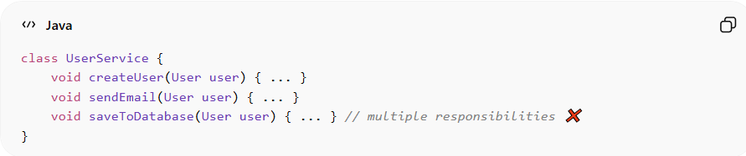
class UserService {
void createUser(User user) { ... }
void sendEmail(User user) { ... }
void saveToDatabase(User user) { ... } // multiple responsibilities ❌
}
Good Example
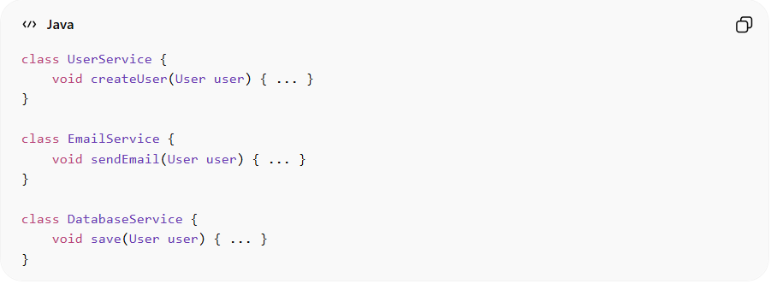
class UserService {
void createUser(User user) { ... }
}

class EmailService {
void sendEmail(User user) { ... }
}

class DatabaseService {
void save(User user) { ... }
}
Benefits:
• Easier to maintain and test
• High cohesion
• Changes in one responsibility don’t affect others

2️⃣ Open/Closed Principle (OCP)
# Source: AI Source: Provided by: [Data Path: Persons Table -> ID Column: 1, Name_En Column: Motasem Essam] -> From: [ChatGPT] on [1/23/2026]
Software entities should be open for extension, but closed for modification. You should be able to add new behavior without changing existing code.
Bad Example
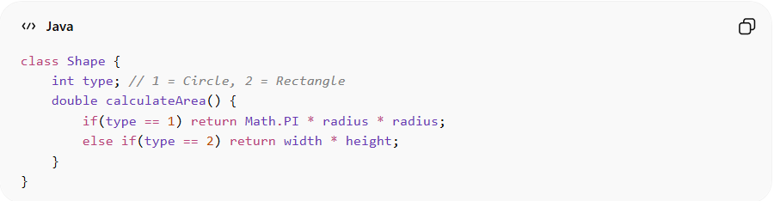
class Shape {
int type; // 1 = Circle, 2 = Rectangle
double calculateArea() {
if(type == 1) return Math.PI * radius * radius;
else if(type == 2) return width * height;
}
}
Good Example
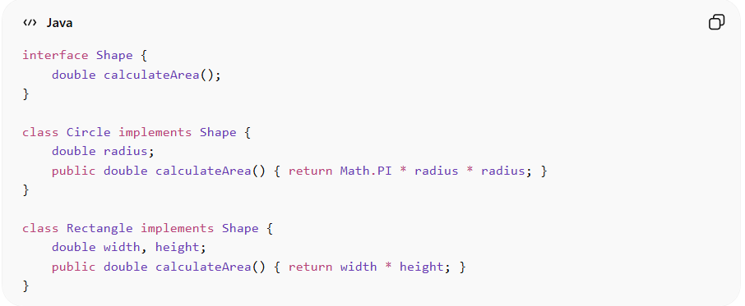
interface Shape {
double calculateArea();
}

class Circle implements Shape {
double radius;
public double calculateArea() { return Math.PI * radius * radius; }
}

class Rectangle implements Shape {
double width, height;
public double calculateArea() { return width * height; }
}
Benefits:
• Add new shapes without modifying existing ones
• Supports extensibility and reduces risk of bugs

3️⃣ Liskov Substitution Principle (LSP)
# Source: AI Source: Provided by: [Data Path: Persons Table -> ID Column: 1, Name_En Column: Motasem Essam] -> From: [ChatGPT] on [1/23/2026]
Subtypes must be substitutable for their base types without altering the correctness of the program.
👉 A subclass should behave like its parent.
Bad Example
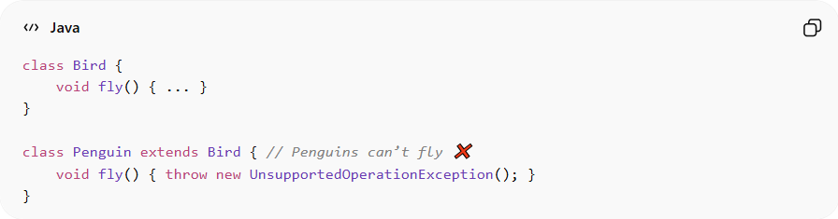
class Bird {
void fly() { ... }
}

class Penguin extends Bird { // Penguins can’t fly ❌
void fly() { throw new UnsupportedOperationException(); }
}
Good Example
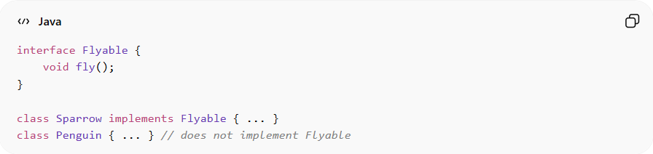
interface Flyable {
void fly();
}

class Sparrow implements Flyable { ... }
class Penguin { ... } // does not implement Flyable
Benefits:
• Ensures correct behavior in polymorphic code
• Reduces runtime errors and surprises

4️⃣ Interface Segregation Principle (ISP)
# Source: AI Source: Provided by: [Data Path: Persons Table -> ID Column: 1, Name_En Column: Motasem Essam] -> From: [ChatGPT] on [1/23/2026]
Clients should not be forced to depend on interfaces they don’t use. Split large interfaces into smaller, specific ones.
Bad Example
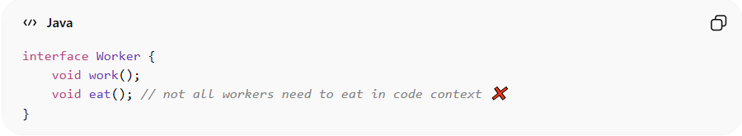
interface Worker {
void work();
void eat(); // not all workers need to eat in code context ❌
}
Good Example
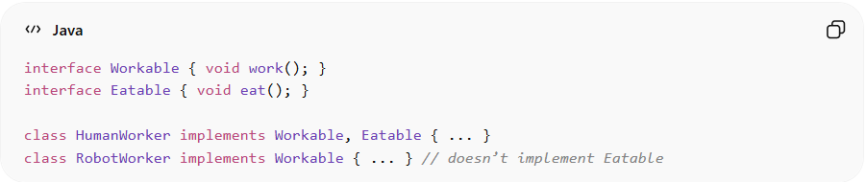
interface Workable { void work(); }
interface Eatable { void eat(); }

class HumanWorker implements Workable, Eatable { ... }
class RobotWorker implements Workable { ... } // doesn’t implement Eatable
Benefits:
• Flexible and modular interfaces
• Reduces unnecessary dependencies
• Makes code easier to implement and maintain

5️⃣ Dependency Inversion Principle (DIP)
# Source: AI Source: Provided by: [Data Path: Persons Table -> ID Column: 1, Name_En Column: Motasem Essam] -> From: [ChatGPT] on [1/23/2026]
High-level modules should not depend on low-level modules. Both should depend on abstractions (interfaces).
👉 Think of it like connecting plugs into sockets via a standard adapter — you rely on the interface, not the specific implementation.
Bad Example
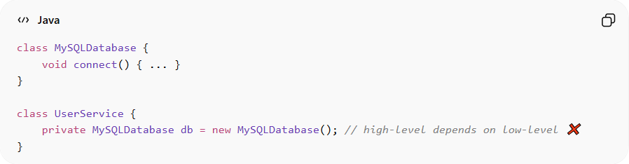
class MySQLDatabase {
void connect() { ... }
}

class UserService {
private MySQLDatabase db = new MySQLDatabase(); // high-level depends on low-level ❌
}
Good Example
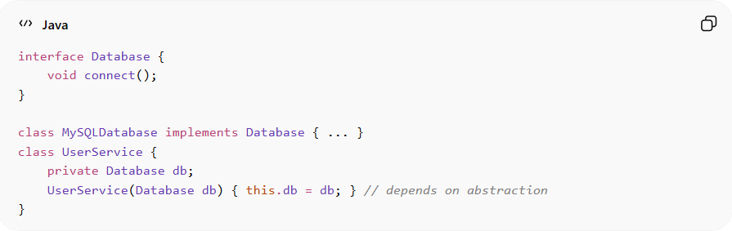
interface Database {
void connect();
}

class MySQLDatabase implements Database { ... }
class UserService {
private Database db;
UserService(Database db) { this.db = db; } // depends on abstraction
}
Benefits:
• High-level modules remain decoupled from implementation details
• Easier to swap implementations
• Supports flexible and testable code

⚡ When to Apply SOLID
# Source: AI Source: Provided by: [Data Path: Persons Table -> ID Column: 1, Name_En Column: Motasem Essam] -> From: [ChatGPT] on [1/23/2026]
• Always — especially in object-oriented and large-scale systems
• Helps reduce technical debt and improve maintainability
• Works best when combined with KISS, DRY, High Cohesion, and IoC

